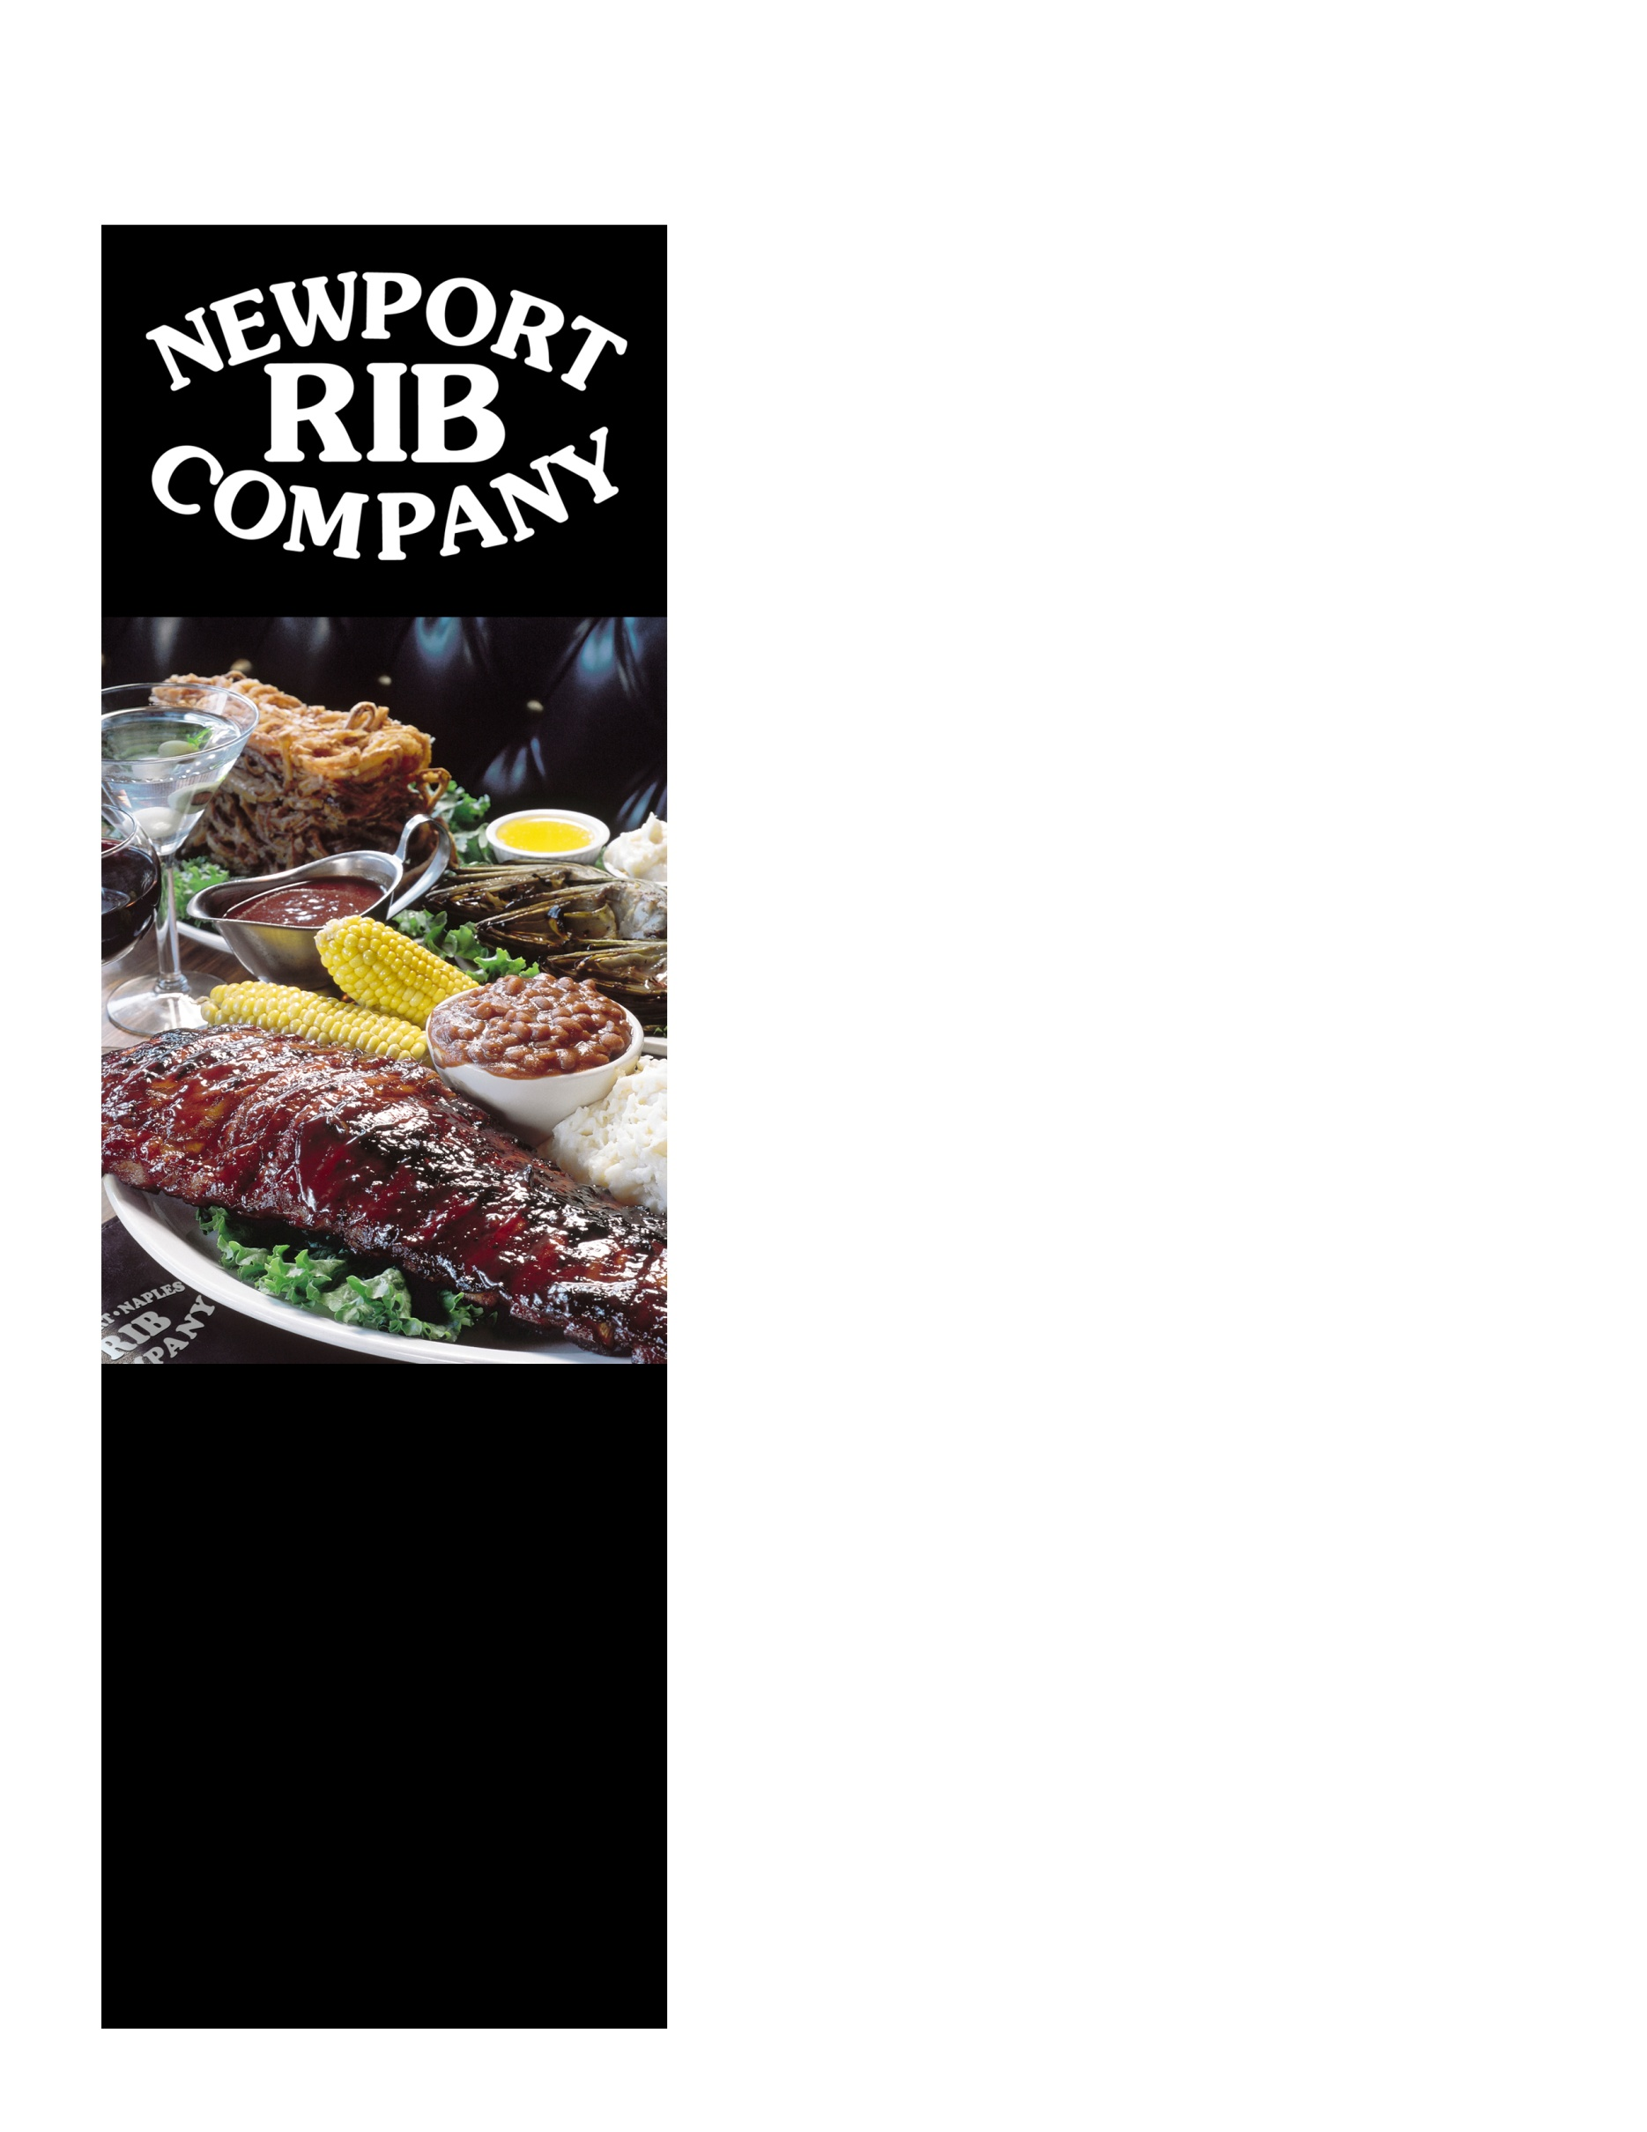
Rib Company Fundraiser Night!

[organization]

[insert fundraiser date(s)]
Take-Out 10am-9pm
Dine-In 4pm-9pm

Please join [insert organization name] for a fundraising event
at Newport Rib Company.
Enjoy great food for a great cause!

Newport Rib Company will donate 20% of your bill to [insert organization name]!
Dine-In or Take-Out

Bring in this flyer OR mention it to the staff,
and they will take care of the rest
Newport Rib Company
2196 Harbor Boulevard
Costa Mesa, CA 92627
(949) 631-2110

www.ribcompany.com

"We Have A Lot
Of Competition...
But Our Ribs Don't"

For reservations, please call
Newport Rib Company (949) 631-2110
Tell them you're with the fundraiser
Online reservations:
www.ribcompany.com/reservations

[logo]

